MCG2101 – Intro Design of MCG Systems

Deliverable 2
Group 13

Names:
Haneen Barghouti
Lara Al Nakeeb
Emma Cochran
Linh Nguyen
Toshio Woo

Step 1 Functions
Overall Function
Design a controlled, stable movement and positioning of a crab-inspired mechanical system to operate on the ocean floor.
Basic Functions
- Crab Movement
  - Locomotion
    - Extend Leg
    - Grip the Environmental Surface
    - Contract Leg
  - Coordinate Legs
- Sampling Mechanism
    - Position Body to Grab
    - Grab the Sample
    - Put the Sample in the Crab
    - Prevent Sample from Escaping
- Buoyancy System
  - Maintain a stable position in water
  - Resist tipping, rolling or sinking
  - Move without being pushed off course
  - Hydrodynamic
    - Minimize sail surfaces
    - Resist torque about horizontal plane
    - Minimize surface friction with water
- Wear Resistance
  - Saltwater Corrosion Resistance
  - Water Pressure Resistance
  - Temperature Resistance
  - Joint Friction Minimization
  - Impact Resistance
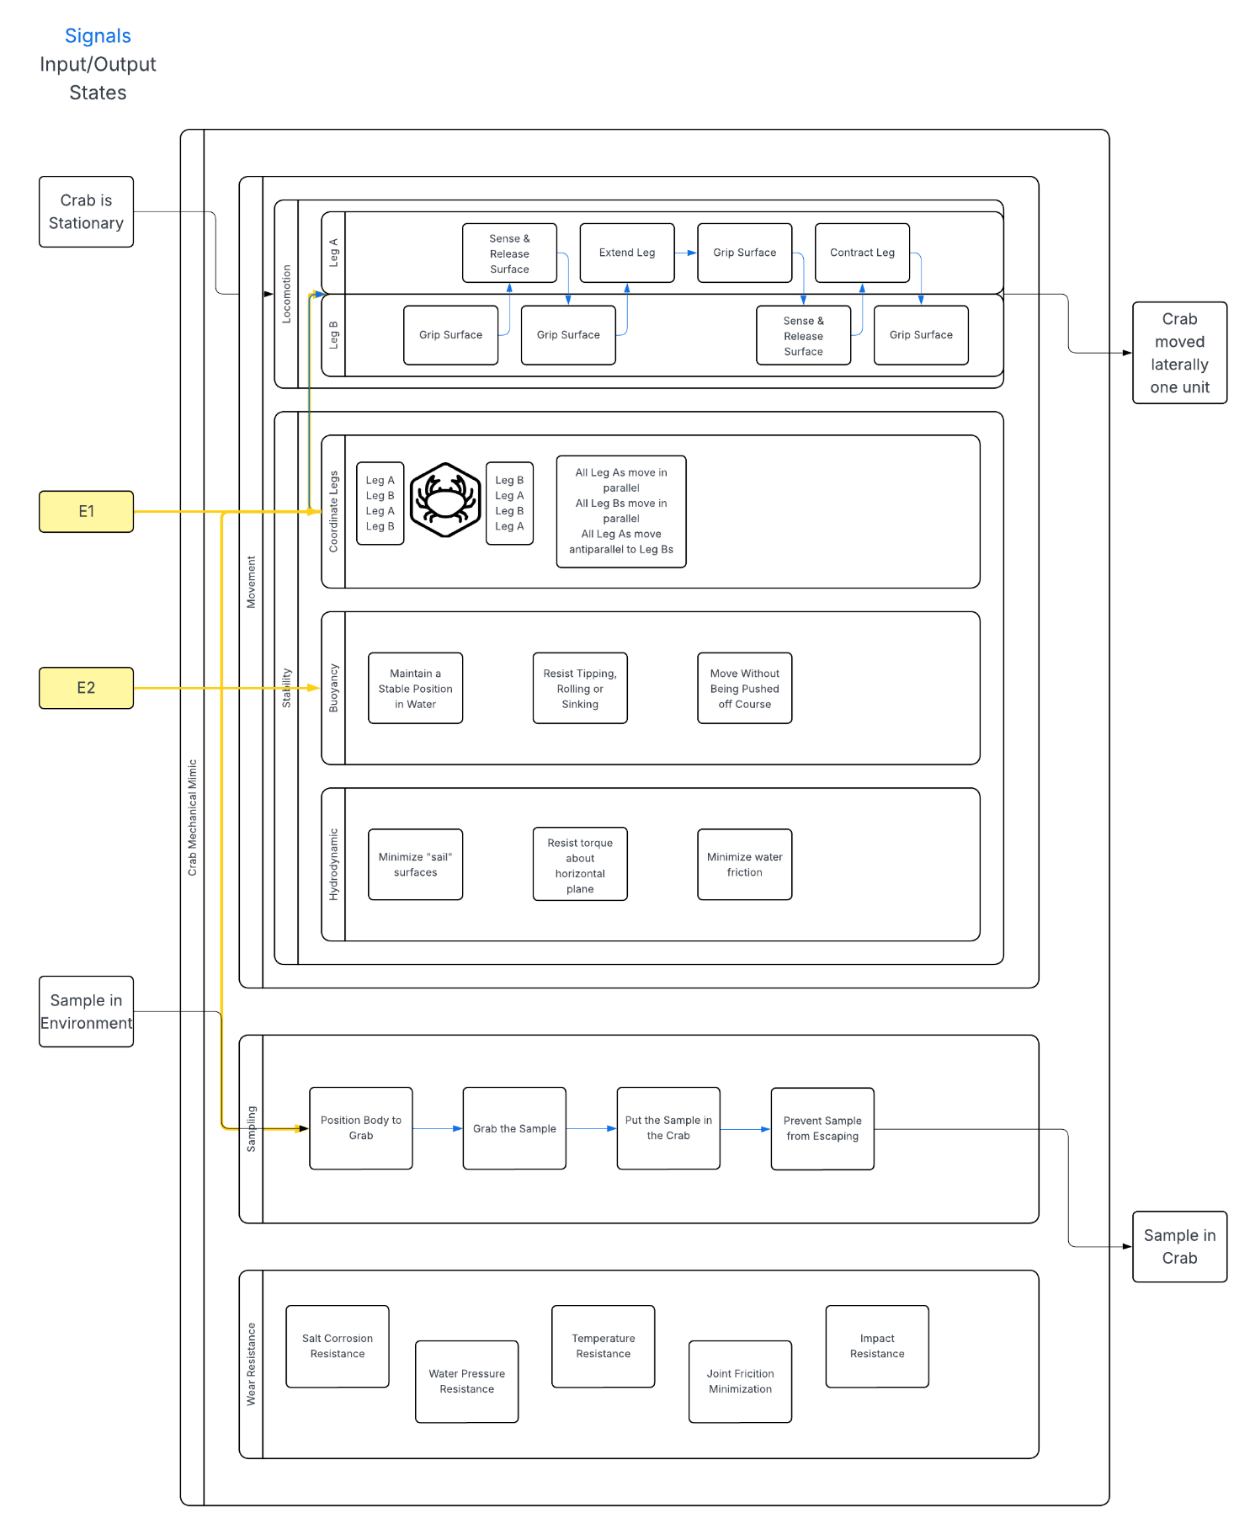

Step 2 Solutions
List of solutions:
- Locomotion Solutions:
  - Four Bar Linkage: 4 bar linkage for legs to maneuver joints driven by a central rotating shaft. The legs are separated into three segments connected by these joints. The input rotational motion converts to leg extension and contraction. This allows for contact then release of the surface and forward propulsion. The movement of adjacent legs is offset to restrict all legs from moving together and ensure ground is always in contact.
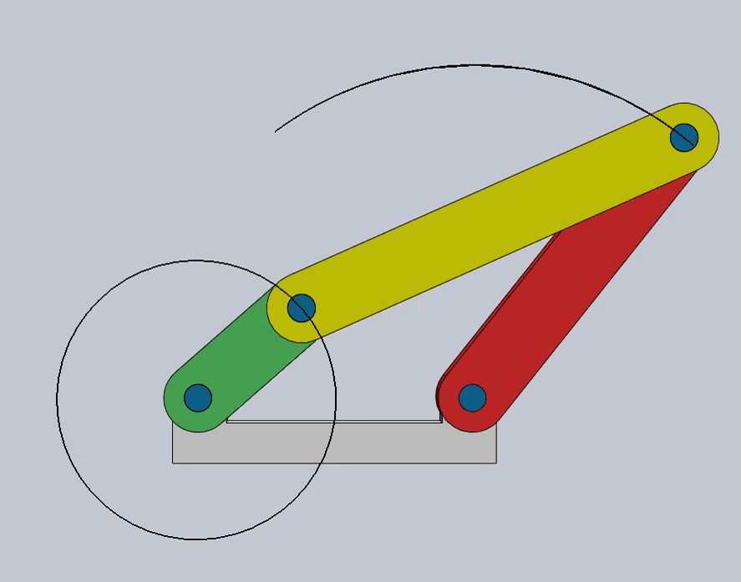
Figure 1. Four Bar Linkage Diagram [1]
  - Cam Driven Slider: Cam and follower actuate a piston slider mechanism to generate linear motion. This will be transmitted through the linkages in the legs to extend and retract them. The movement of adjacent legs will be offset to keep them from moving all together and for the legs to be able to propel the spy crab forward.
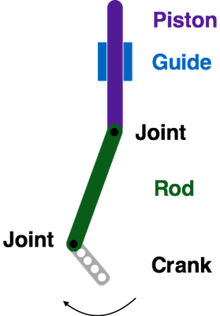
Figure 2. Cam Driven Slider Diagram [2]
  - Klann Linkage: Consists of a combination of two four-bar linkages that work in tandem to increase the range of motion of the foot into a triangular shape.
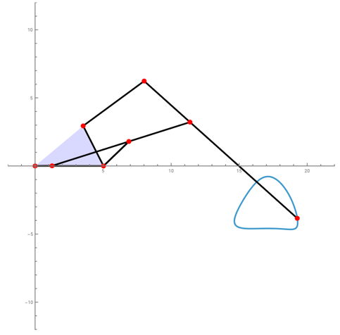
Figure 3. Klann Linkage Diagram [3]

- Sampling Mechanism:
  - Spring Deployed Scoop: Hinged rectangular scoop mounted at the underside of the crab deployed by a spring mechanism to gather samples. The scoop will be perforated to avoid collecting sand. The sample is directed to a chamber within the spy crab’s body with rubber flaps at the opening and the sample is pushed inside once the scoop is back in place.
  - Retractable Brush: A system stored in the claws of the crab will open to expose a brush. The brush will move in various motions to collect debris. Once debris is collected the brush will retreat into the crab claw to protect and store the samples until they are taken to be tested.
  - Gear Actuated Tube: A small sample tube with an Archimedes screw will be stored on the underside of the crab and will be deployed using internal gears. Once the sample tube makes contact with the seafloor, the screw will activate, pulling samples into the tube before returning to the inside of the crab using the reverse direction of the gears. A perpendicular cover will ensure the sample is sealed.

- Buoyancy System:
  - Buoyancy Chamber: A system consisting of a compressed air canister, two valves, balloon, and water cavity inside the crab’s structure is used to modulate the buoyant force. When the water chamber is half-filled with water, the crab maintains a neutral buoyant force; when water levels exceed this, the crab will sink, when the water exits this chamber, it will float. Compressed air from a canister will flow through a valve into a balloon that inflates, pushing the water out of the water chamber to increase buoyancy. Another valve is used to release the air from the balloon while blocking water from entering the pneumatic system to reestablish negative buoyancy.
  - External Inflatable Balloon: A system consisting of compressed air, two valves, and a balloon modulates the buoyant force by blowing up a balloon that is tethered to the crab. When the balloon is deflated, the crab is negatively buoyant, but when the balloon is inflated, the crab is positively buoyant.
  - Reservoir and Pump System: A system consisting of internal reservoirs and pumps will adjust the buoyancy by changing the amount of water that is pumped into the valve. When there is no water in the valves the crab will float. When water is pumped into the valves the crab will sink to the ocean floor.

- Wear Resistance:
  - Internal Trusses: A system of internal truss supports will support the crab against impacts and external pressures by distributing loads away from weak areas to areas with more load bearing capability while not adding extra weight
  - Wear Resistant Material: 2205 Duplex Stainless Steel provides a corrosion resistant, high yield strength material that is suited for the particular environmental and wear conditions.
  - Sacrificial Surfaces: To reduce the risk of sudden high impact forces, sacrificial surfaces can be used which will fall off the crab structure given a high force, avoiding kinetic energy transfer into the crab body itself.

- Stability:
  - Pin-Ended Penetration Leg: Each leg is attached to a pin or spike to penetrate soft river bottom surface such as sand. The leg applies a downward force to anchor the crab. Once the crab needs to lift the leg the pin is lifted and repositioned for the next step. This helps to prevent slipping and improve stability.
  - Spring Joint Tolerances: Each bar will be connected to the joint by a spring mechanism that will tolerate uneven surfaces for different legs while preventing any limb-joint dislocations. If one leg extends further than another, a spring will compensate for the differences in extension to maintain the crab’s neutral tilt.
  - Large Friction Contact Surface: Each leg ends with a toothed pad that increases friction against the surface to oppose slip.

Part 3 Combination Table
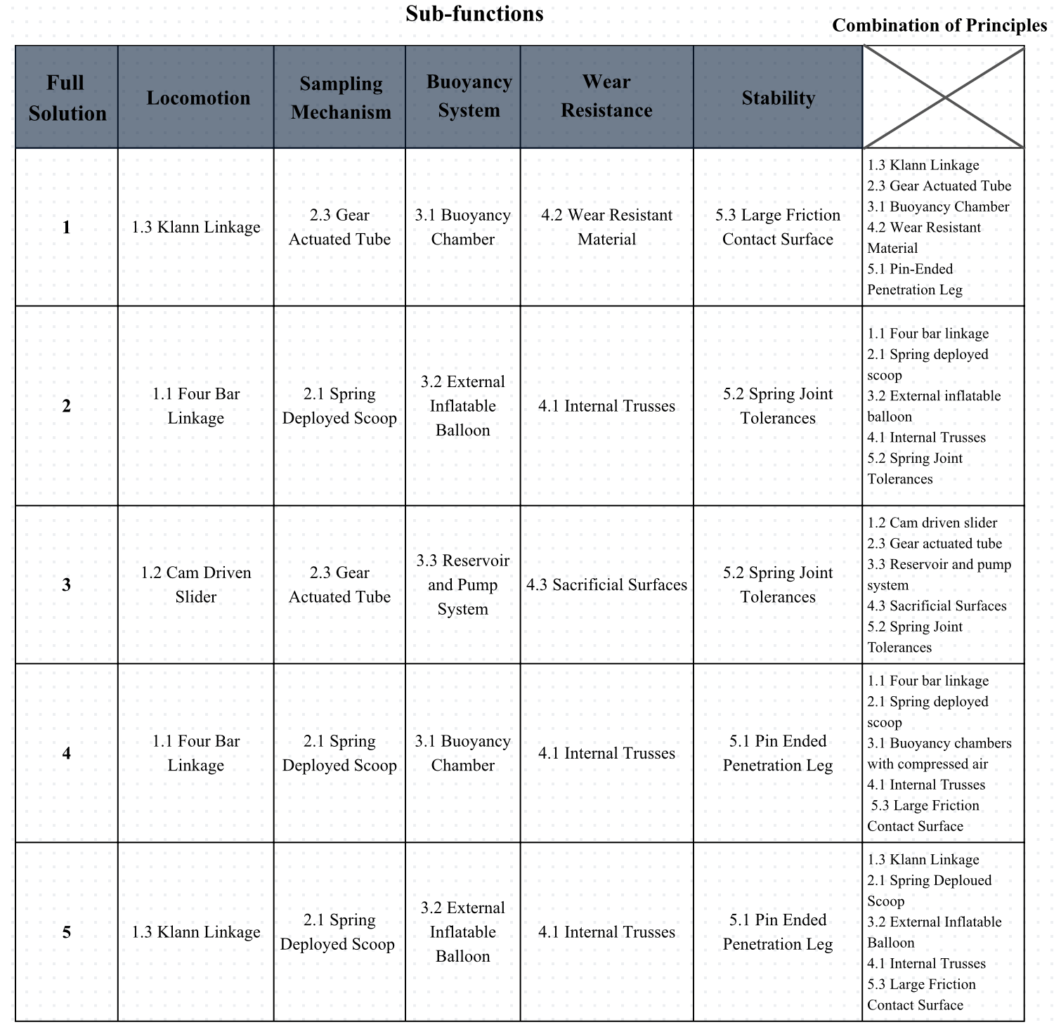
Figure 4. Combination Table

Bibliography

[1] J. Moran, 'M1: Linkages', Ottawa, ON, Canada, 2026

[2] “Mechanisms: Cranks with Pistons.” BirdBrain Technologies, learn.birdbraintechnologies.com/hummingbirdduo/projects/mechanisms/mechanisms-cranks-with-pistons/.
[3] E. Mahieu, “Wolfram Demonstrations Project,” Wolfram.com, 2025. https://demonstrations.wolfram.com/WalkingMechanismUsingAKlannLinkage/ (accessed Feb. 09, 2026).

